# **Document Function:**

* Describe the setup of both raspberry pi servers needed for the hardware model to function properly in our environment.
* Note: additional servers may be configured to allow for redundancy however, this will not be covered in this documentation because it is not needed in this case.

# **Server Setup**

*Note: Server Setup is used for both the Node-Red server and SQL / LAMP server setup.

* Prerequisites
  + Documentation assumes that the raspberry pi has been setup with Raspbian OS.
  + You must have prior working knowledge of Linux
* General OS Setup
  + Localization Settings *change to your current location
    - Navigate to the below area:
      * Start>Preferences>Raspberry Pi Configuration>Localization
      * Reboot when finished

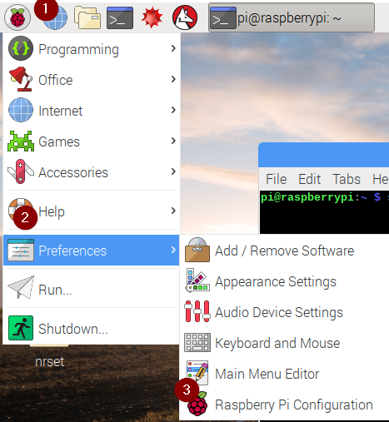 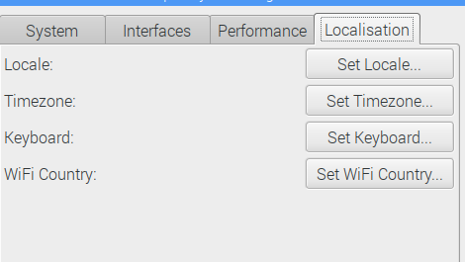

* Update the OS to the latest version
  + Open a terminal and type the below command to update the raspberry pi with the latest software and repositories.
    - sudo apt-get update | sudo apt-get upgrade -y
  + Reboot when finished.

# **Node-Red Server Setup**

* Prerequisites:
  + Please reference the Server Setup portion of this document before continuing further
* Copy the ‘nrset’ folder to the pi user desktop </home/pi/desktop/>
* Select all of the files that are in the ‘nrset’ folder that is on the desktop and then right click and click properties.
  + Navigate to the permissions menu and set access control to ‘Anyone’ for all three choices. (see below)

## 

* Run the st1.sh from the terminal and accept all of the prompts. ** do not use sudo
  + /home/pi/desktop/nrset/st.sh

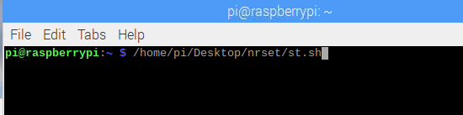

* After the script has finished running, reboot the pi
* At this point enter Node-Red from either a networked computer or there raspberry pi its self.
  + Remote: **your.ip.here.please:1880**
  + Local: **localhost:1880**
* Login to Node-Red with the below credentials.
  + Username: admin
  + Password: Noded

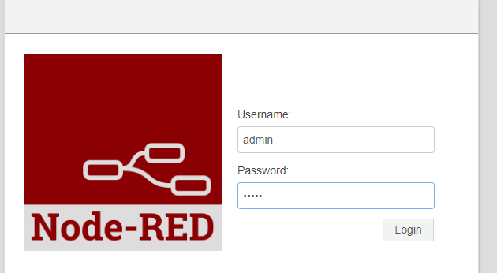

* After you have logged into the web page navigate to settings>Manage palette

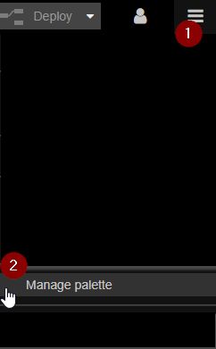

* Once you are in the Palette manager, navigate to ‘install’.
  + Copy and paste the below nodes into the search bar to find them.
  + Click install in the lower right hand corner of the node.

**\*\*\* Be sure to leave this screen open as it installs the node. Some nodes can take up to 30 minutes to install!!! ONLY install one at a time!!!\*\*\***

* + - Node-red-contrib-bigtimer
    - Node-red-dashboard
    - Node-red-contrib-mqtt-broker
    - Node-red-contrib-camerapi
    - Node-red-contrib-usbcamera
    - Node-red-node-mysql

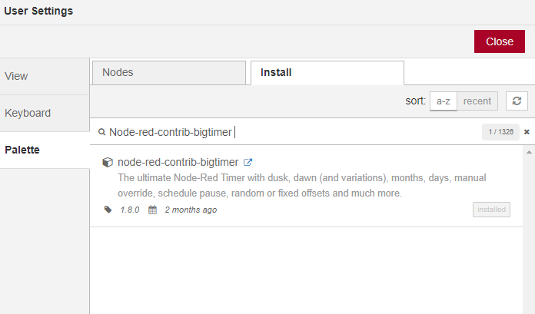

# **LAMP Server Setup**

* Prerequisites:
  + Please reference the Server Setup portion of this document before continuing further
* Copy the ‘lampset’ folder to the pi user desktop </home/pi/desktop/>
* Select all of the files that are in the ‘lampset’ folder that is on the desktop and then right click and click properties.
  + Navigate to the permissions menu and set access control to ‘Anyone’ for all three choices. (see below)

## 

* Run the st1.sh from the terminal and accept all of the prompts. ** do not use sudo
  + /home/pi/desktop/lampset/st1.sh

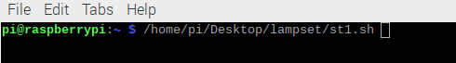

* Either use the existing terminal window or open a new one and type the below commands ** use default Pi user and pass info to run below if asked.
  + sudo su
  + mysql -u root -p
  + GRANT ALL ON *.* TO 'nodered' @'192.168.1.%' IDENTIFIED BY 'nodered' with grant option;
  + Exit
  + Exit
* Run the st2.sh from the terminal and accept all of the prompts. ** do not use sudo
  + /home/pi/desktop/lampset/st2.sh

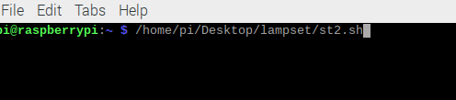

* Reboot the pi